**4.2** I have merged columns first name and last name. 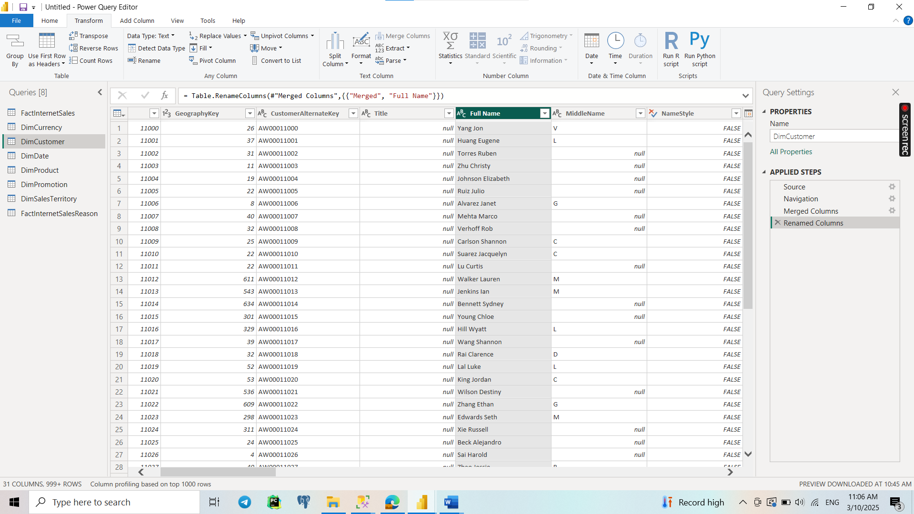

I have changed type to percentage.

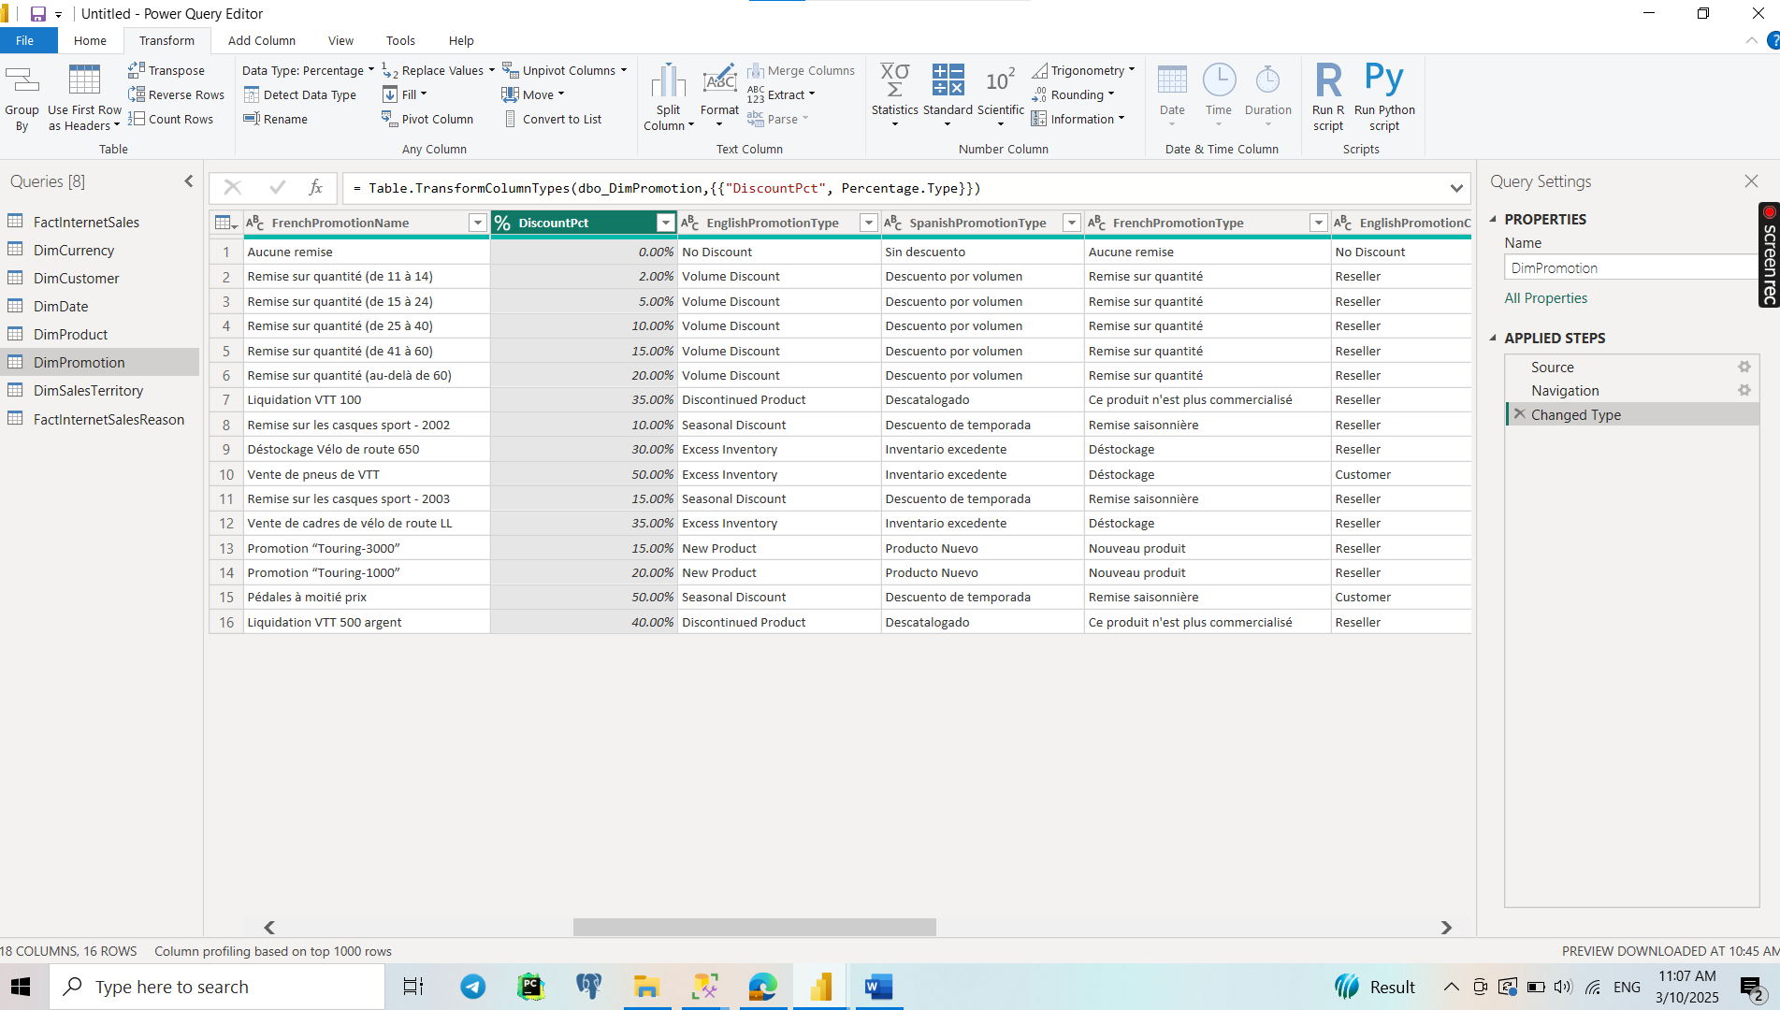

I have created a Custom Column with formula subtraction end date from start date.

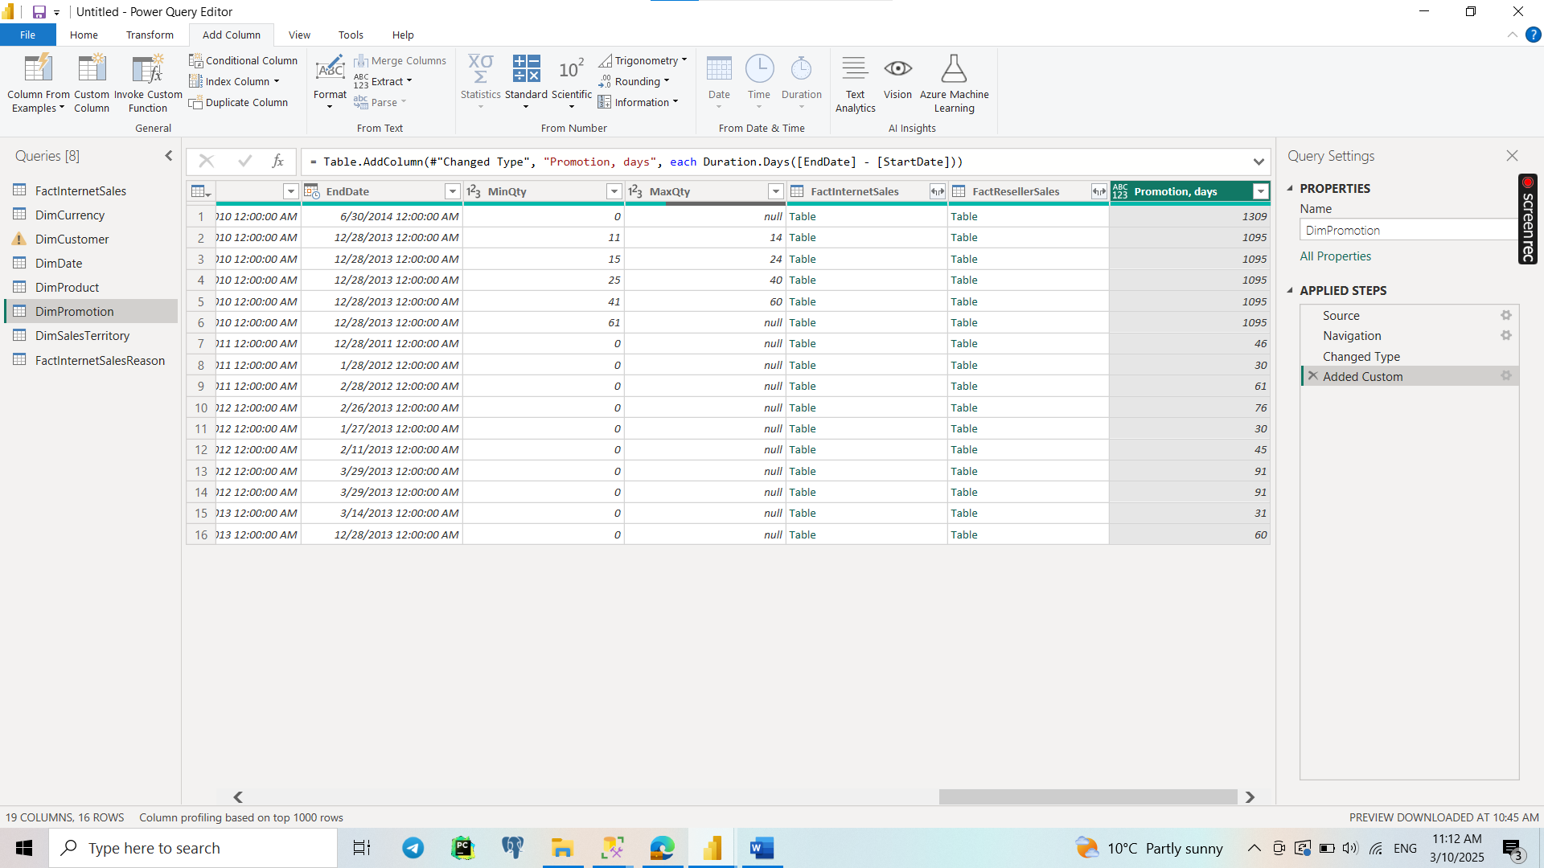

**4.3** I have loaded additionally ‘DimProductSubcategory’ and ‘DimProductCategory’ tables 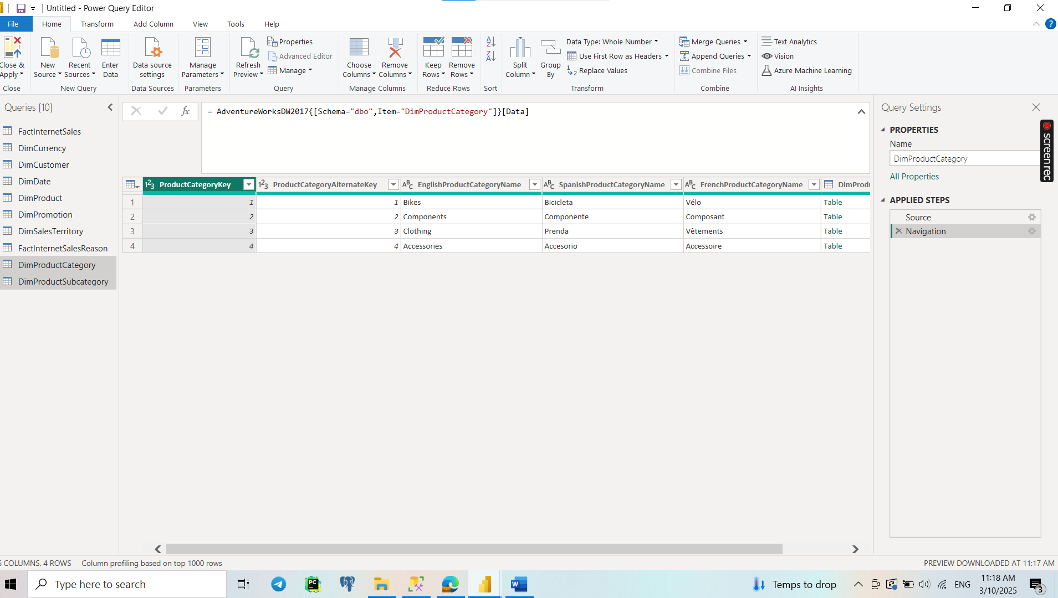

**4.4** In View I have selected options Column Quality, Column distribution and Column profile.

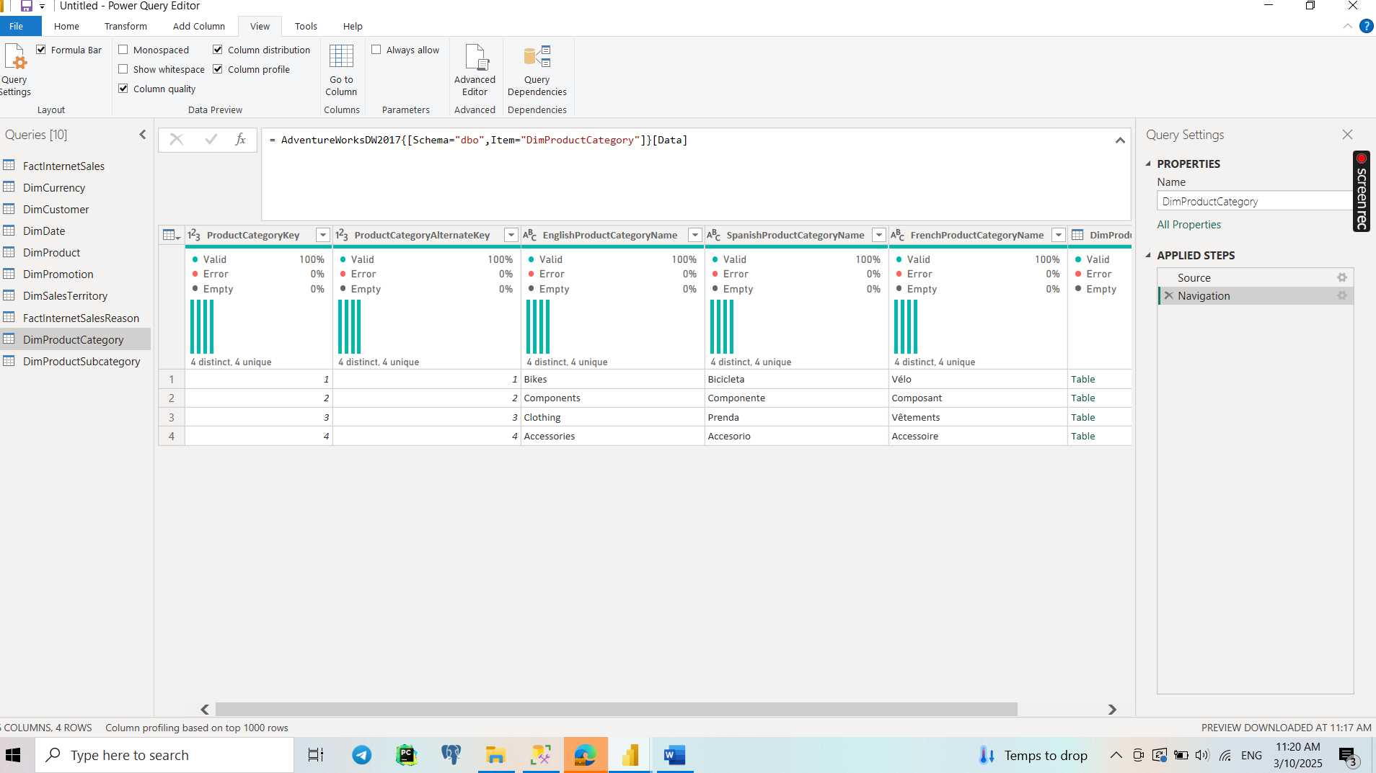

**4.5** I have extracted year from the ‘OrderDate’ column.

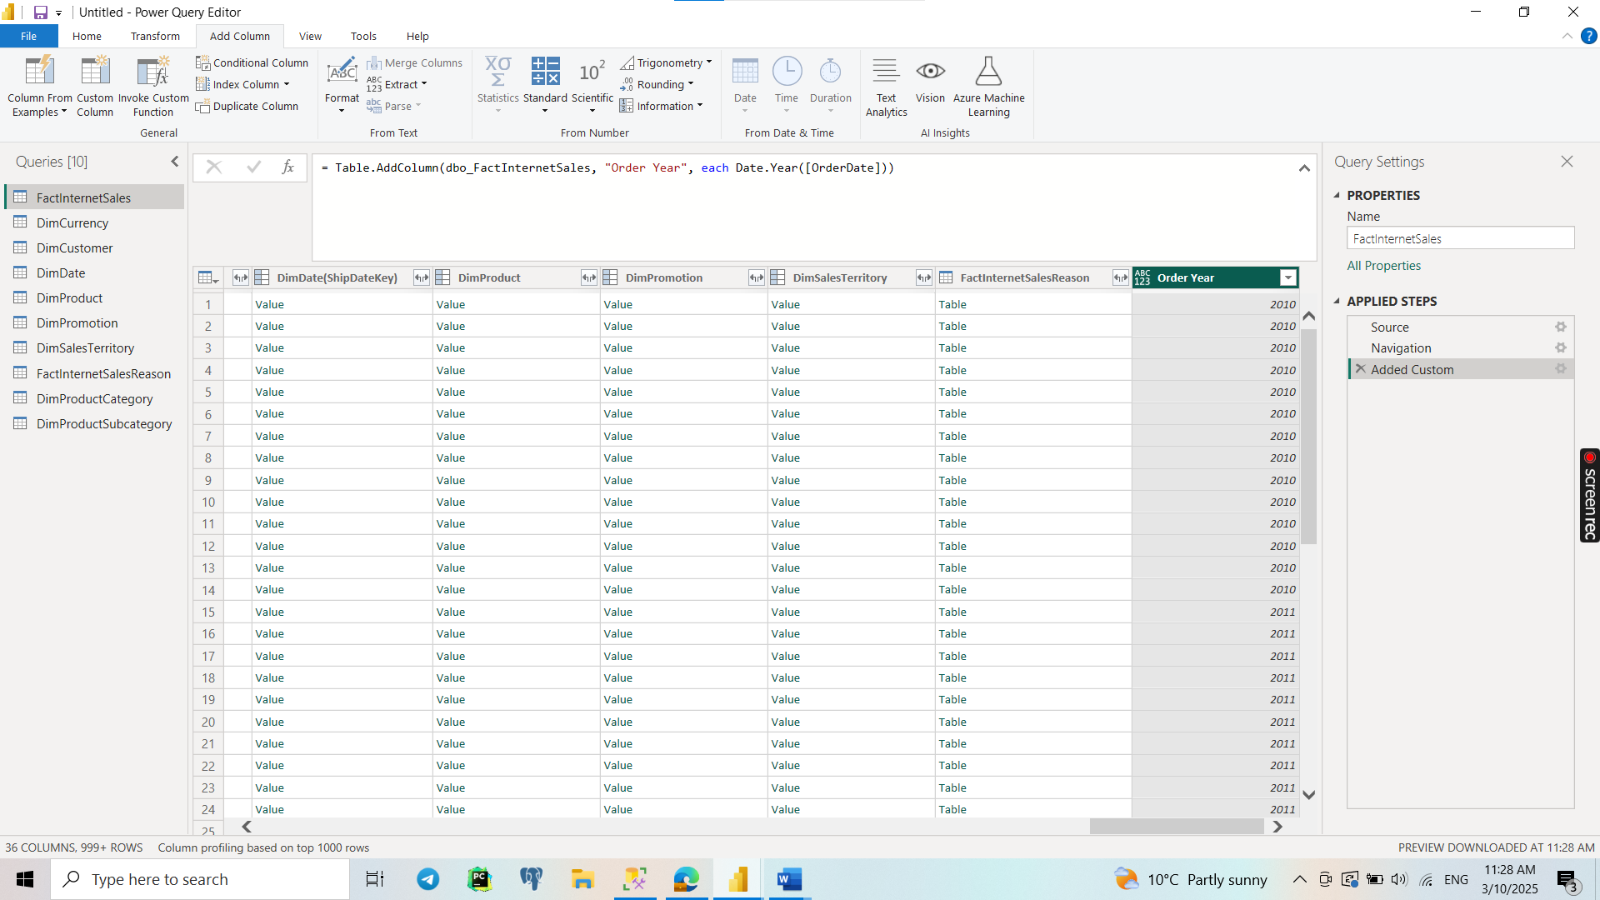

I have created a new table ‘SalesByYearsNPrice’.

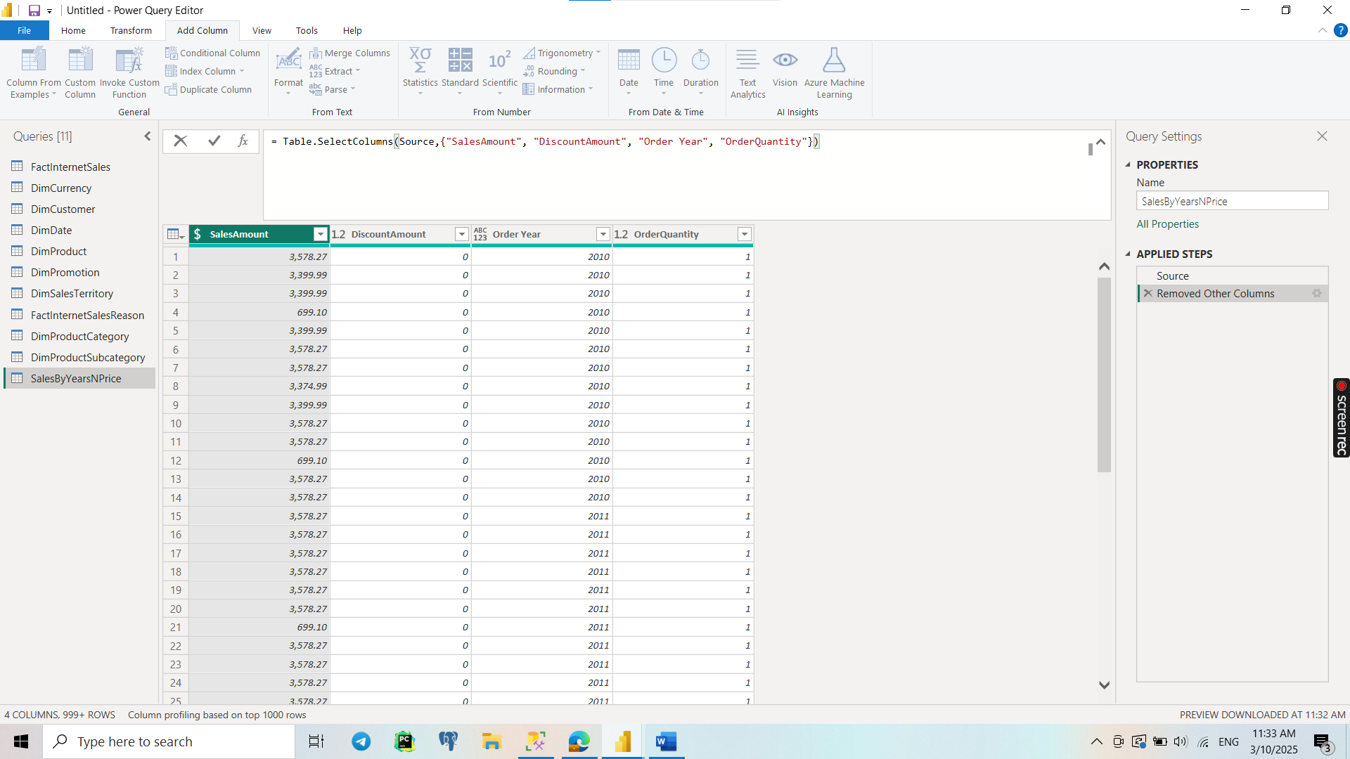

I have created Pivot Column.

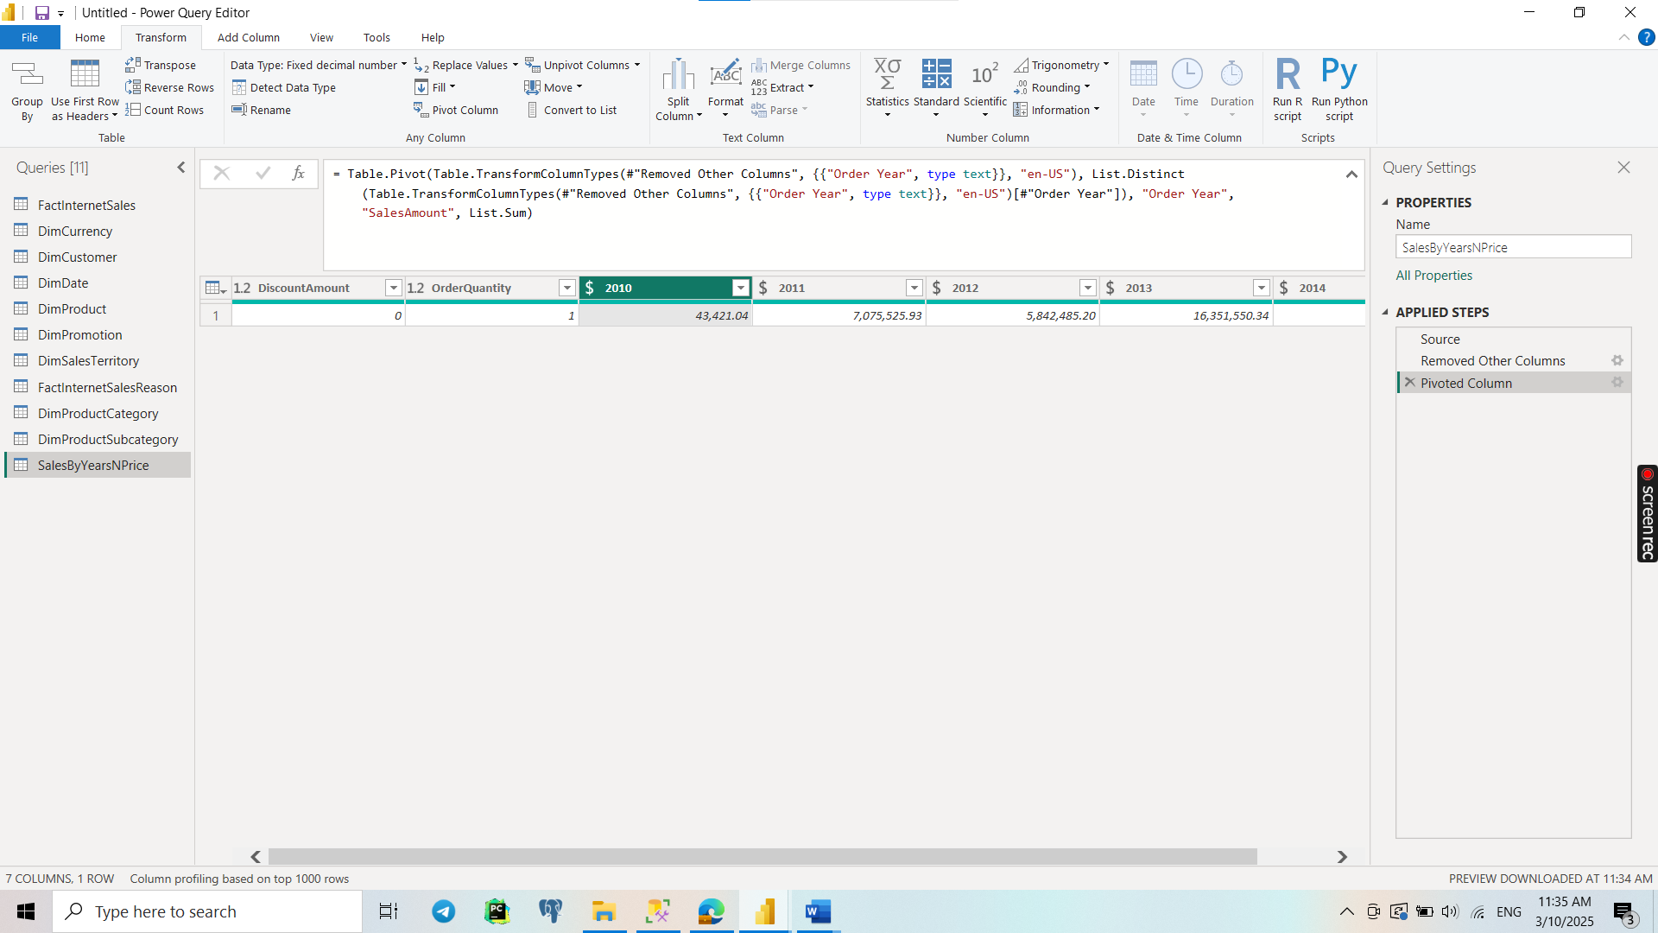

**4.6** I have created a new table ‘SalesByCountry’ joined with ‘DimSalesTerritory’, ‘DimProduct’, ‘DimProductSubcategory’, ‘DimProductCategory.’

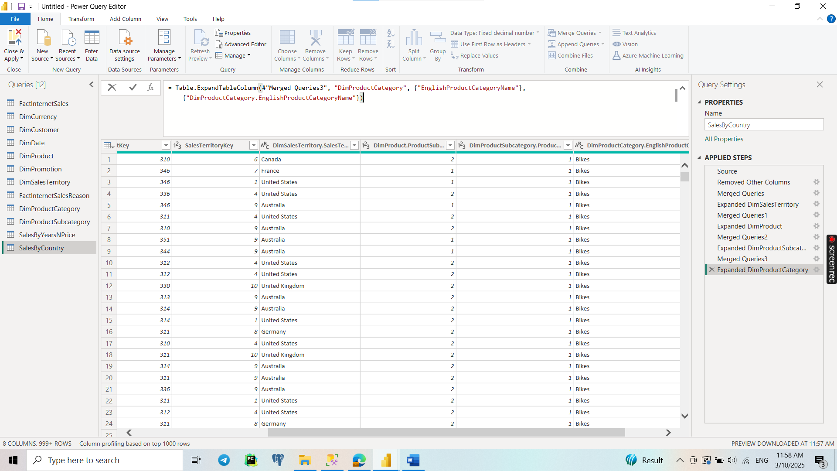

**4.7** I have grouped data into ‘Sales’ column.

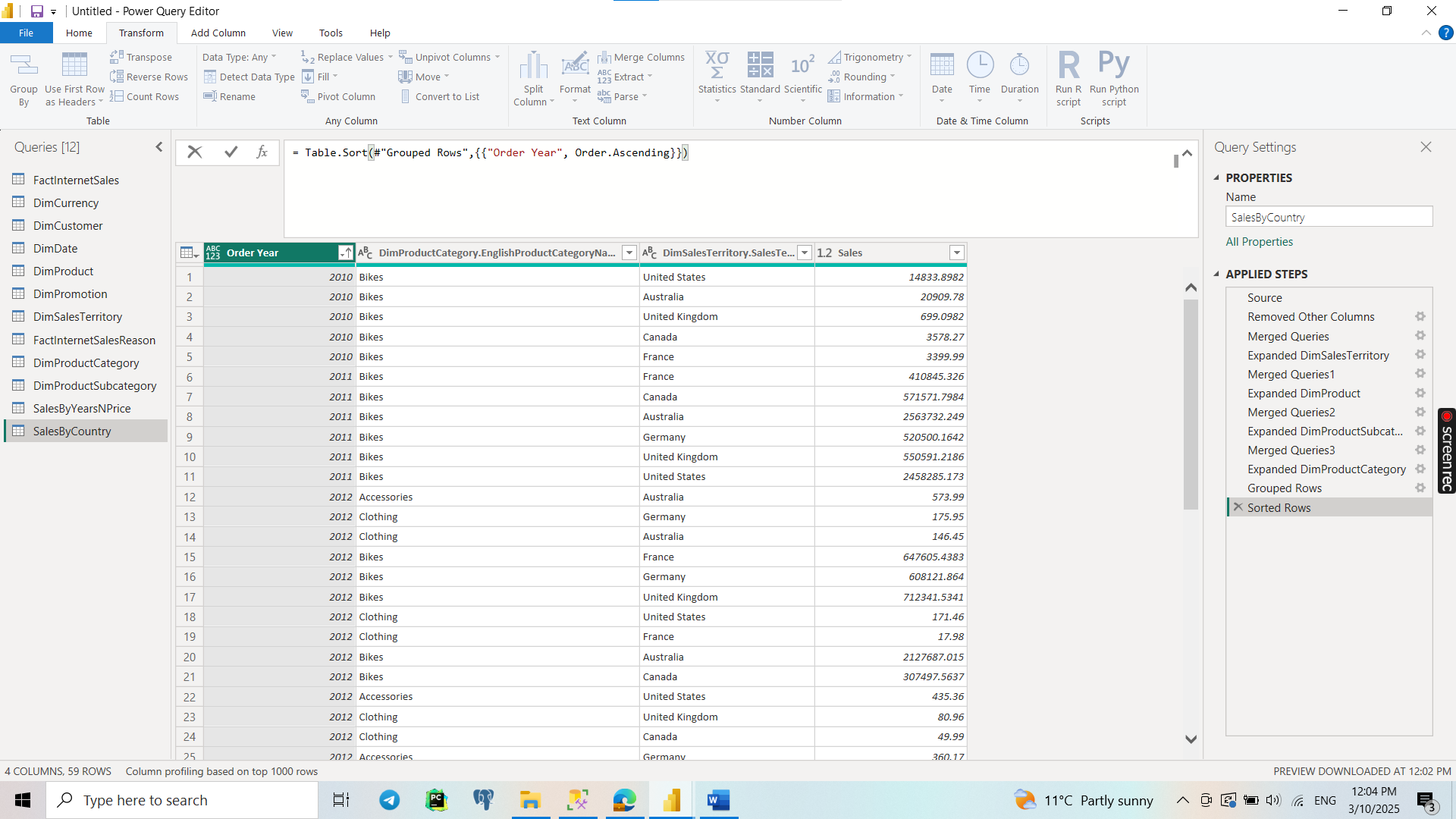

**4.7** **Differences Between Import and Direct Query**

| **Feature** | **Import Mode** | **Direct Query Mode** |
| --- | --- | --- |
| **Data Storage** | Data is fully imported and stored in Power BI. | Data remains in the source and queries run in real time. |
| **Performance** | Faster performance as queries run on cached data. | Slower performance since each query is sent to the database. |
| **Data Freshness** | Needs scheduled refreshes to update data. | Always up-to-date, reflecting changes in the source instantly. |
| **File Size** | Larger file size due to stored data. | Smaller file size since no data is stored. |
| **Transformation** | Full support for Power Query transformations. | Limited transformation support due to query restrictions. |
| **DAX Calculations** | Faster calculations using in-memory storage. | Limited performance for complex DAX calculations. |
| **Security** | Requires Row-Level Security (RLS) in Power BI. | Can leverage database-level security. |

**4.8** 